Experiment Number : 8 Date: 11.02.2020

Implementation of Packages in Java

Aim:
Write a Java program to implement built-in, user-defined packages and accessing all classes in a package.

PRE LAB EXERCISE
QUESTIONS
- What is java.util package and what collection framework does it contain?
java.util is a built-in Java package that provides utility classes for common programming tasks like:
- Data structures
- Date & time
- Random numbers
- Scanner (input)
- Collections
It contains the Collection Framework, which provides ready-made classes and interfaces to store and manipulate groups of objects such as:
- Interfaces: List, Set, Queue, Map
- Classes: ArrayList, LinkedList, HashSet, TreeSet, HashMap, TreeMap, PriorityQueue
It helps in easy data storage, searching, sorting, and manipulation.

- What are the two types of packages in Java?
Java packages are of two types:
- Built-in (Predefined) Packages
  - Provided by Java API
  - Examples:
    - java.lang
    - java.util
    - java.io
    - java.net
- User-defined Packages
  - Created by the programmer
  - Used to organize classes in projects
  - Improves code management and reusability

IN LAB EXERCISE
Objective
To understand and implement the concepts of built-in, user-defined packages and accessing all classes in a package in Java.
Built-in Packages comprise a large number of classes that are part of the Java API. Some of the commonly used built-in packages are:
- java.lang: Contains language support classes(e.g, classes that define primitive data types, math operations). This package is automatically imported.
- java.io: Contains classes for supporting input/output operations.
- java.util: Contains utility classes that implement data structures such as Linked Lists and Dictionaries, as well as support for date and time operations.
- java.applet: Contains classes for creating Applets.
- java.awt: Contains classes for implementing the components for graphical user interfaces (like buttons, menus, etc).
Source Code
import java.util.Random; // built-in package
public class Sample{
public static void main(String[] args) {
// using Random class
Random rand = new Random();
// generates a number between 0–99
int number = rand.nextInt(100);
System.out.println("Random number: " + number);
}
}
Output
Random number: 49
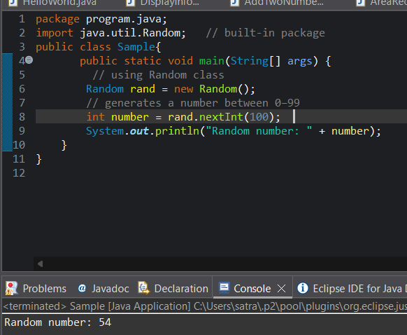

User-defined Packages are the packages that are defined by the user.
Source code
package com.myapp;
public class Helper {
public static void show() {
System.out.println("Hello from Helper!");
}
}
==To use this in another class==
import com.myapp.Helper;
public class Test {
public static void main(String[] args) {
Helper.show();
}
}

Output:
Hello from Helper!
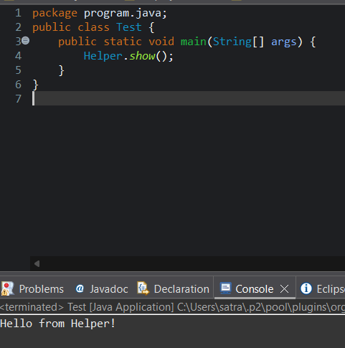

//Importing all classes from a package.
Source code
import java.util.Vector;
public class Coders {
public Coders() {
// java.util.Vector is imported, We are able to access it directly in our code.
Vector v = new Vector();
java.util.ArrayList l = new java.util.ArrayList();
l.add(3);
l.add(5);
l.add(7);
System.out.println(l);
}
public static void main(String[] args) {
new Coders();
}
}
Output
[3,5,7]
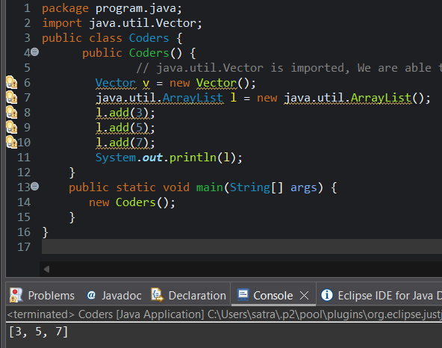
POST LAB EXERCISE
- What will happen if two classes in different packages have the same name and are imported in a Java file?
If two classes with the same name from different packages are imported, Java will get confused and throw a compile-time error (ambiguous reference).

Solution: Use the fully qualified class name for one of them.
Example:
java.util.Date d1;
java.sql.Date d2;

- What is the purpose of using packages in Java?
Packages are used to:
- Organize related classes and interfaces
- Avoid class name conflicts
- Provide access control (security)
- Improve code reusability
- Make large projects easier to manage

- Which built-in Java package would you use if you want to create a GUI window and display a message?

- java.util
- java.sql
- java.awt
- java.net
The Abstract Window Toolkit (AWT) package is used to create GUI components like windows, buttons, labels, and dialogs.
- java.util → utilities & collections
- java.sql → database connectivity
- java.awt → GUI components ✅
- java.net → networking

ASSESSMENT

Description | Max Marks | Marks Awarded
Pre Lab Exercise | 5
In Lab Exercise | 10
Post Lab Exercise | 5
Viva | 10
Total | 30
Faculty Signature

Experiment Number : 9 Date: 11.02.2026

Implementation of a Java Program to import packages using different methods

Aim:
Write a Java program to import packages using different methods for different use cases.

PRE LAB EXERCISE
QUESTIONS
- How to import a single class and multiple classes from a package in Java?
Import a single class:
import java.util.Scanner;
Import multiple (all) classes from a package:
import java.util.*;
* means import all classes from that package.
- Which package is always imported by default in every Java class?
The package that is automatically imported by Java is:
java.lang
You don’t need to write import java.lang.*; because Java imports it by default.
Examples of classes from java.lang: String, System, Math, Object, Exception.

IN LAB EXERCISE
Objective
To understand and implement the Java packages using different methods and import them.
Problem
Define a package named ‘useFul’ with a class names ‘UseMe’ having following methods:
1) area()- To calculate the area of given shape.
2) salary()- To calculate the salary given basic Salary,da,hRA.
3) percentage()-To calculate the percentage given total marks and marks obtained.
4) Develop a program named ‘Package Use’ to import the above package ‘useFul’ and use the method area().
5) Develop a program named ‘manager’
Source Code
//Package Creation:
package useFull;
import java.util.*;
public class UseMe
{
Scanner obj=new Scanner(System.in);
public static void area()
{
class method{
void aos(int a)
{
System.out.print("\nArea of square with length "+a+" is "+(a*a));
}
void aor(int a,int b)
{
System.out.print("\nArea of reactangle with dimensions "+a+" & "+b+" is "+(a*b));
}
void aoc(int r)
{
double a=3.14*r*r;
}
System.out.print("\nArea of circle with radius "+r+" is "+a);
}
void aot(int a,int b)
{
float ar=(a*b)/2;
System.out.print("\nArea of triangle with dimensions "+a+" &"+b+" is "+ar);
} }
Scanner obj=new Scanner(System.in);
method m=new method();
System.out.print("\n1.Square\n2.Rectangle\n3.Circle\n4.Triangle\nSelect the shape\n");
int ch=obj.nextInt();
UseMe u=new UseMe();
switch(ch)
{
case 1:System.out.print("\nEnter the length of side of square : ");
int s=obj.nextInt();m.aos(s);
break;
case 2:System.out.print("\nEnter the dimensions of rectangle : ");
int l=obj.nextInt();
int b=obj.nextInt();
m.aor(l,b);
break;
case 3:System.out.print("\nEnter the radius of circle : ");
int r=obj.nextInt();
m.aoc(r);
break;
case 4:System.out.print("\nEnter the dimensions of triangle : ");
int ba=obj.nextInt();
int w=obj.nextInt();
m.aot(ba,w);
break; } }
public void salary()
{
int ba,da,hra;
System.out.print("\nEnter the basic salary : ");
ba=obj.nextInt();
System.out.print("\nEnter the dearness allowance :");
da=obj.nextInt();
System.out.print("\nEnter the house rent allowance : ");
hra=obj.nextInt();
System.out.print("\nThe total Gross salary of employee is : "+(ba+da+hra));
}
public void percentage()
{
int n,sum=0;
float p;
System.out.print("\nEnter the total number of subjects : ");
n=obj.nextInt();
int m[]=new int[n];
System.out.print("\nEnter the marks of "+n+" subjects : ");
for(int i=0;i<n;i++)
{
m[n]=obj.nextInt();
}
for(int i=0;i<n;i++)
{
sum=sum+m[i];
}
p=sum/n;
{
System.out.print("\nPercentahe of student : "+p);
}
}
}
//Package Implementation-1:
import useFull.UseMe;
class packageUse
{
public static void main(String args[])
{
UseMe o=new UseMe();o.area();
}
}

Output
javac packageUse.java
java packageUse
- Square
- Rectangle
- Circle
- Triangle
Select the shape
2

Enter the dimensions of the rectangle: 10 15
Area of the rectangle with dimensions 10&15 is 150
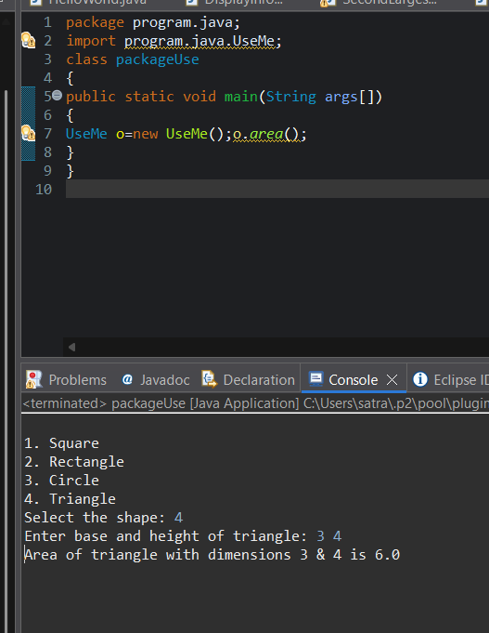
//Package Implementation-2:
import useFull.UseMe;
class manager
{
public static void main(String args[])
{
UseMe obj=new UseMe();obj.salary();
}
}

Output
javac manager.java
java manager

Enter the basic salary: 100000
Enter the dearness allowance: 5000
Enter the house rent allowance: 2000
The total Gross salary of employee is: 107000
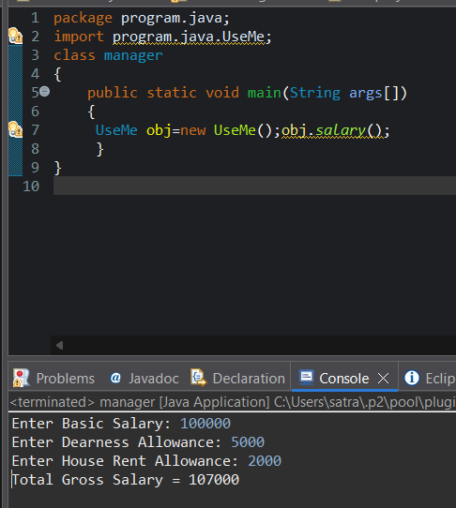

POST LAB EXERCISE
- Find the key differences between java.util and java.lang packages.
Feature | java.lang | java.util
Import | Imported by default | Must be imported explicitly
Purpose | Core language support | Utility & helper classes
Main use | Basic classes needed by every program | Data structures, utilities, input
Examples | String, System, Math, Object, Exception | Scanner, ArrayList, HashMap, Date, Random
Collection Framework | ❌ Not present | ✅ Present
Summary:
- java.lang provides fundamental classes used in almost every Java program and is auto-imported.
- java.util provides utility classes and Collection Framework for handling data, input, and operations on groups of objects.

- List some of the subpackages of java.util
Here are commonly used subpackages of java.util:
- java.util.concurrent → Multithreading utilities (Executor, Locks)
- java.util.regex → Pattern matching using regular expressions
- java.util.stream → Stream API for functional-style operations on collections
- java.util.function → Functional interfaces (Predicate, Function, etc.)
- java.util.zip → Compression & ZIP file utilities
These subpackages extend java.util for advanced tasks like concurrency, streams, regex, and file compression.

ASSESSMENT

Description | Max Marks | Marks Awarded
Pre Lab Exercise | 5
In Lab Exercise | 10
Post Lab Exercise | 5
Viva | 10
Total | 30
Faculty Signature

Experiment Number : 10 Date: 25.02.2026

Implementation of Access Modifiers in Java

Aim:
Write a Java program to implement different access modifiers.

PRE LAB EXERCISE
QUESTIONS
- What are the 4 access modifiers available in Java?
Java provides four access levels:
- private
  - Accessible only within the same class
  - Used for data hiding (encapsulation)
- default (no modifier)
  - Accessible within the same package only
  - If you don’t write any modifier, this is applied automatically
- protected
  - Accessible within the same package
  - Also accessible in subclasses (child classes) in other packages
- public
  - Accessible from anywhere (inside and outside the package)

- Which access modifiers can be used in Java to control access to class members?
For class members (variables, methods, constructors), Java allows all four access modifiers:
Modifier | Can be used for class members?
private | Yes
default | Yes
protected | Yes
public | Yes

IN LAB EXERCISE
Objective
To demonstrate different access modifiers such as Default, Private, Protected and Public using Java programs.
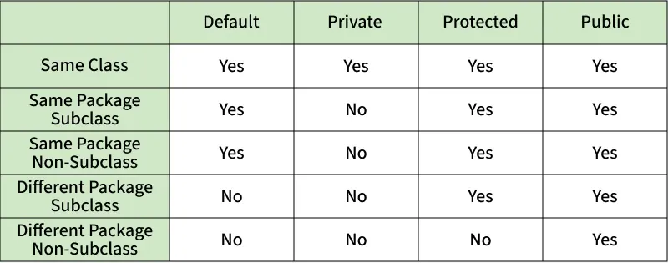
Fig: Comparison table of Access Modifiers in Java
Source Code
// Default Access modifier
class Car {
String model; // default access
}
public class Main {
public static void main(String[] args){
Car c = new Car();
c.model = "Tesla"; // accessible within the same package
System.out.println(c.model);
}
}
Output:
Tesla
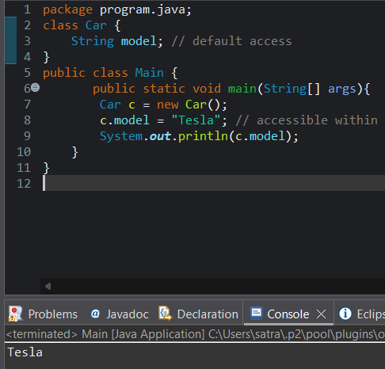

//Private Access Modifier
class Person {
// private variable
private String name;
public void setName(String name) {
this.name = name; // accessible within class
}
public String getName() {
return name;
}
}
public class Geeks {
public static void main(String[] args)
{
Person p = new Person();
p.setName("Alice");

// System.out.println(p.name);
// Error: 'name'
// has private access
System.out.println(p.getName());
}
}
Output
Alice
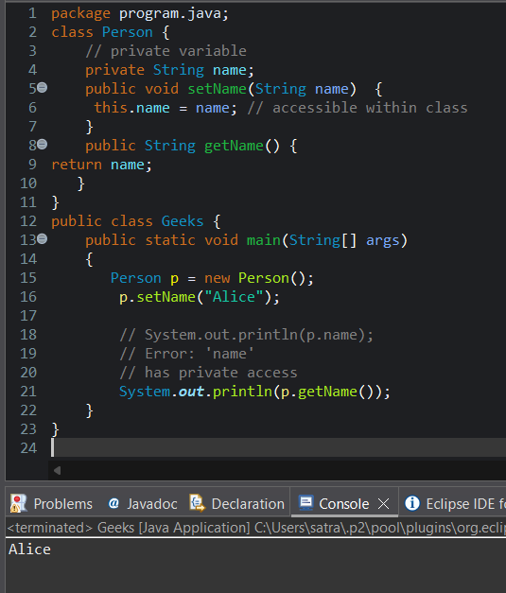

//Protected Access Modifier
class Vehicle {
protected int speed; // protected member
}
class Bike extends Vehicle {
void setSpeed(int s)
{
speed = s; // accessible in subclass
}
int getSpeed()
{
return speed; // accessible in subclass
}
}
public class Main {
public static void main(String[] args){
Bike b = new Bike();
b.setSpeed(100);
System.out.println("Access via subclass method: "+ b.getSpeed());
Vehicle v = new Vehicle();
System.out.println(v.speed);
}
}
Output
Access via subclass method: 100
0
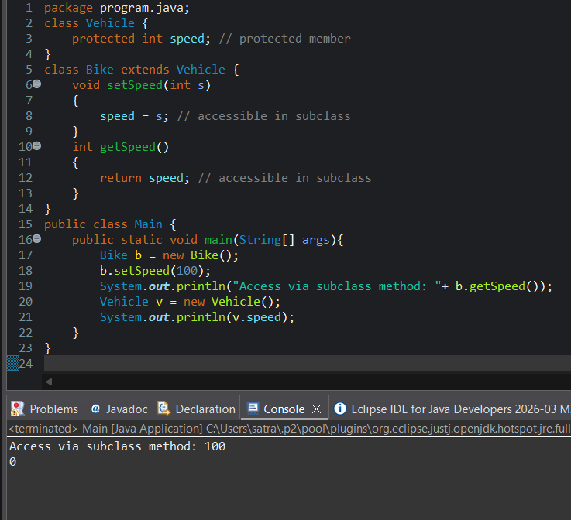

//Public Access Modifier
class MathUtils {
public static int add(int a, int b) {
return a + b;
}
}
public class Main {
public static void main(String[] args) {
System.out.println(MathUtils.add(5, 10)); // accessible anywhere
}
}
Output
15
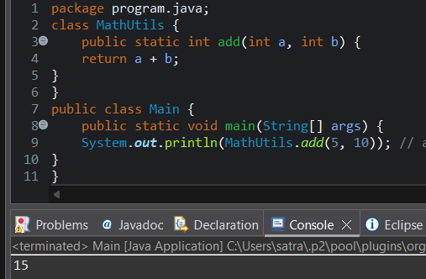

POST LAB EXERCISE
  - Write a Java program to implement Default access modifier which has a default class within the same package and a default class from a different package.
Package 1: mypack1
File: DefaultClass.java
package mypack1;

// default access class (no public keyword)
class DefaultClass {
void show() { // default access method
System.out.println("Hello from DefaultClass (same package)");
}
}

File: SamePackageTest.java
package mypack1;

public class SamePackageTest {
public static void main(String[] args) {
DefaultClass obj = new DefaultClass();
obj.show();
}
}
Package 2: mypack2
File: DifferentPackageTest.java
package mypack2;
import mypack1.DefaultClass;
public class DifferentPackageTest {
public static void main(String[] args) {
DefaultClass obj = new DefaultClass();
obj.show();
}
}
A default access class and its members are not accessible outside the package.
Output (only same package program runs)
Hello from DefaultClass (same package)

  - Which access modifier provides the highest level of access?
public provides the highest level of access.
Reason:
- public members can be accessed:
  - within the same class
  - within the same package
  - in subclasses
  - from other packages

ASSESSMENT

Description | Max Marks | Marks Awarded
Pre Lab Exercise | 5
In Lab Exercise | 10
Post Lab Exercise | 5
Viva | 10
Total | 30
Faculty Signature

Experiment Number :11 Date: 25.02.2026

Implementation of multiple inheritance in Java using Interface

Aim:
Write a Java program to implement multiple inheritance using Interface.

PRE LAB EXERCISE
QUESTIONS
- Why Java does not support multiple inheritance using classes like that of C?
Java does not support multiple inheritance with classes to avoid ambiguity and complexity, especially the Diamond Problem, where the compiler cannot decide which parent class method to inherit.

- What is the primary purpose of an interface in Java?
- To store data using instance variables
- To define a contract of methods a class must implement
- To allow creation of objects
- To improve runtime performance
Correct Answer:
B. To define a contract of methods a class must implement
The primary purpose of an interface in Java is to define a contract of methods that implementing classes must follow, ensuring consistency and abstraction.

IN LAB EXERCISE
Objective
To demonstrate how an interface in Java defines constants and abstract methods, which are implemented by a class.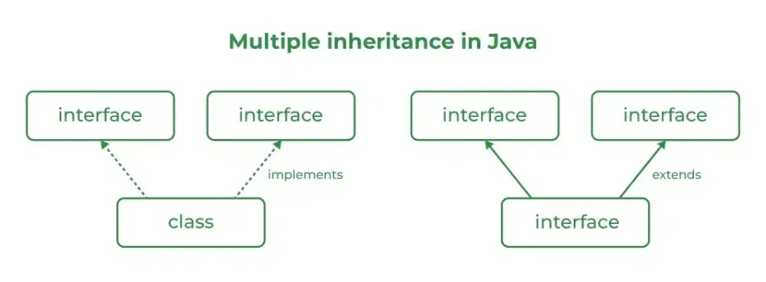

Source Code
import java.io.*;
// Add interface
interface Add{
int add(int a,int b);
}
// Sub interface
interface Sub{
int sub(int a,int b);
}
// Calculator class implementing Add and Sub
class Cal implements Add , Sub
{
// Method to add two numbers
public int add(int a,int b){
return a+b;
}
// Method to sub two numbers
public int sub(int a,int b){
return a-b;
}
}
class Example{
// Main Method
public static void main (String[] args){

// instance of Cal class
Cal x = new Cal();
System.out.println("Addition : " + x.add(2,1));
System.out.println("Substraction : " + x.sub(2,1));
}
}

Outputs
Addition : 3
Subtraction : 1
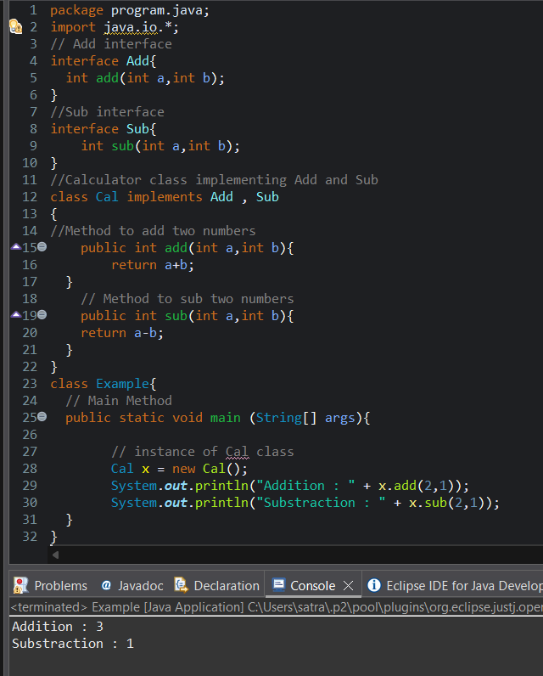

POST LAB EXERCISE
  - Can a functional interface extend another interface?
Yes, a functional interface can extend another interface in Java.
However, after extending, it must still contain only one abstract method in total.
If extending another interface adds more abstract methods, then it will no longer be considered a functional interface.

  - Which feature was introduced in interfaces starting from Java 8?
- Constructors
- Private methods
- Default and static methods
- Final classes

Correct Answer:
C. Default and static methods
From Java 8, interfaces can contain default and static methods, which allow method implementations inside interfaces

ASSESSMENT

Description | Max Marks | Marks Awarded
Pre Lab Exercise | 5
In Lab Exercise | 10
Post Lab Exercise | 5
Viva | 10
Total | 30
Faculty Signature

Experiment Number : 12 Date: 25.02.2026

Implementation of exception handling in Java
Aim:
Write a java program to implement exception handling.

PRE LAB EXERCISE
QUESTIONS
- What is exception handling in Java?
Exception handling in Java is a mechanism to handle runtime errors so that the normal flow of the program is maintained. It prevents program termination by handling exceptions using try, catch, finally, throw, and throws.
- What is the purpose of using try-catch blocks in exception handling?
The purpose of using try-catch blocks is to detect and handle exceptions that may occur during program execution. The try block contains code that may cause an exception, and the catch block handles the exception to prevent abnormal termination of the program.

IN LAB EXERCISE
Objective
To understand and implement exception handling through try-catch and finally blocks.
Source Code
import java.util.InputMismatchException;
import java.util.Scanner;
public class ExceptionHandlingExample {
public static void main(String[] args) {
Scanner scanner = new Scanner(System.in);
try {
System.out.print("Enter an integer: ");
int num = scanner.nextInt();
int result = 10 / num;
System.out.println("Result: " + result);
} catch (InputMismatchException e) {
System.out.println("Invalid input! Please enter an integer.");
} catch (ArithmeticException e) {
System.out.println("Cannot divide by zero!");
} finally {
scanner.close();
System.out.println("Program execution completed.");
} }
}
Outputs
Output 1 (Valid Input - Non-zero Integer):
Enter an integer: 5
Result: 2
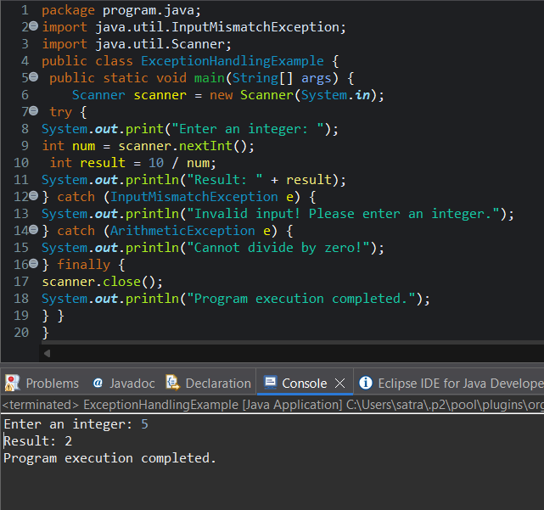
Program execution completed.
Output 2 (Valid Input - Zero):
Enter an integer: 0
Cannot divide by zero!
Program execution completed.
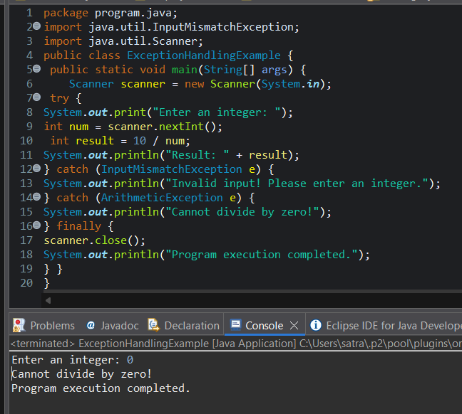

Output 3 (Invalid Input - Non-integer):
Enter an integer: abc
Invalid input! Please enter an integer.
Program execution completed.
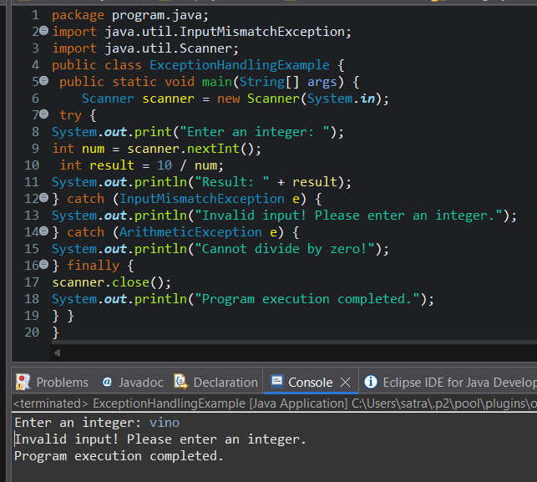

POST LAB EXERCISE
- What is the purpose of the Scanner object in the Java program?
The Scanner object is used to read input from the user (such as integers, strings, etc.) from standard input (System.in) during program execution.

- What exceptions are expected to be thrown in the code within the try block? Why?
Common exceptions expected inside a try block when using Scanner are InputMismatchException and NoSuchElementException.
These occur when the user enters an input of the wrong data type or when no input is available, respectively.

ASSESSMENT

Description | Max Marks | Marks Awarded
Pre Lab Exercise | 5
In Lab Exercise | 10
Post Lab Exercise | 5
Viva | 10
Total | 30
Faculty Signature

Experiment Number : 13 Date: 25.02.2026

Implementation of User-defined Exception in Java

Aim:
Write a java program to implement User-defined Exception.

PRE LAB EXERCISE
QUESTIONS
- What is Java custom exception?
A Java custom exception is a user-defined exception created by extending either the Exception class or the RuntimeException class to handle specific error conditions in a program.
- What are the two types of custom exceptions in Java?
2. Two Types of Custom Exceptions in Java
Custom exceptions in Java can be classified into two types:
- Checked Custom Exception
  - Extends the Exception class.
  - Must be declared in the method signature using throws or handled using try-catch.
  - Example: class MyCheckedException extends Exception { ... }
- Unchecked Custom Exception
  - Extends the RuntimeException class.
  - No need to declare or handle explicitly. It can propagate at runtime.
  - Example: class MyUncheckedException extends RuntimeException { ... }

IN LAB EXERCISE
Objective
To understand and implement Checked and Unchecked custom exceptions.
Source Code
Ex 1: // Custom Checked Exception
class InvalidAgeException extends Exception {
public InvalidAgeException(String m) {
super(m);
}
}
// Using the Custom Exception
public class AgeCheck{
public static void validate(int age)
throws InvalidAgeException {
if (age < 18) {
throw new InvalidAgeException("Age must be 18 or above.");
}
System.out.println("Valid age: " + age);
}
public static void main(String[] args) {
try {
validate(12);
} catch (InvalidAgeException e) {
System.out.println("Caught Exception: " + e.getMessage());
}
}
}

Output 1
Caught Exception: Age must be 18 or above.
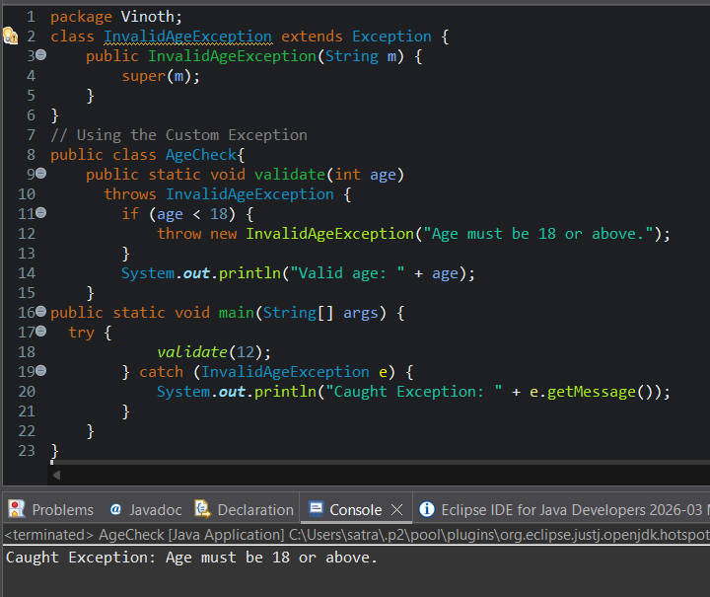

Ex 2: // Custom Unchecked Exception
class DivideByZeroException extends RuntimeException {
public DivideByZeroException(String m) {
super(m);
}
}
// Using the Custom Exception
public class TestSample {
public static void divide(int a, int b) {
if (b == 0) {
throw new DivideByZeroException("Division by zero is not allowed.");
}
System.out.println("Result: " + (a / b));
}
public static void main(String[] args) {
try {
divide(10, 0);
} catch (DivideByZeroException e) {
System.out.println("Caught Exception: " + e.getMessage());
}
}
}

Output 2
Caught Exception: Division by zero is not allowed.
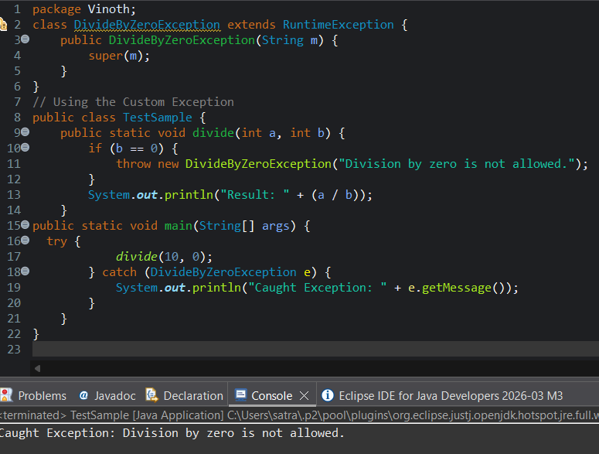

POST LAB EXERCISE
- What is required to create a custom exception in Java?
- Extend the Object class
- Extend the Throwable class
- Extend Exception or RuntimeException
- Implement the Serializable interface
Answer:
C. Extend Exception or RuntimeException ✅
- To create a custom exception, you extend either Exception (for checked exceptions) or RuntimeException (for unchecked exceptions).
- List some use cases for the checked and unchecked exceptions.
Use Cases for Checked and Unchecked Exceptions
Type | Typical Use Cases
Checked Exception | - File handling (FileNotFoundException)  - Database operations (SQLException)  - Invalid input that the caller can recover from
Unchecked Exception | - Programming errors like NullPointerException  - Arithmetic errors like divide by zero  - Invalid method calls or illegal arguments

ASSESSMENT

Description | Max Marks | Marks Awarded
Pre Lab Exercise | 5
In Lab Exercise | 10
Post Lab Exercise | 5
Viva | 10
Total | 30
Faculty Signature

